DAV Institute of Engineering and Technology, Jalandhar
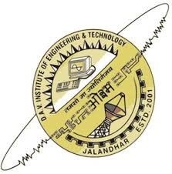
Department of Computer Science and Engineering (AIML)
Training Report on
“BRAIN TUMOR DETECTOR”

Submitted in partial fulfillment of the requirements for the award of the degree of

BACHELOR OF TECHNOLOGY
In
COMPUTER SCIENCE AND ENGINEERING - AIML

Submitted By
Palakpreet Kaur
738/23
2301997

CERTIFICATE

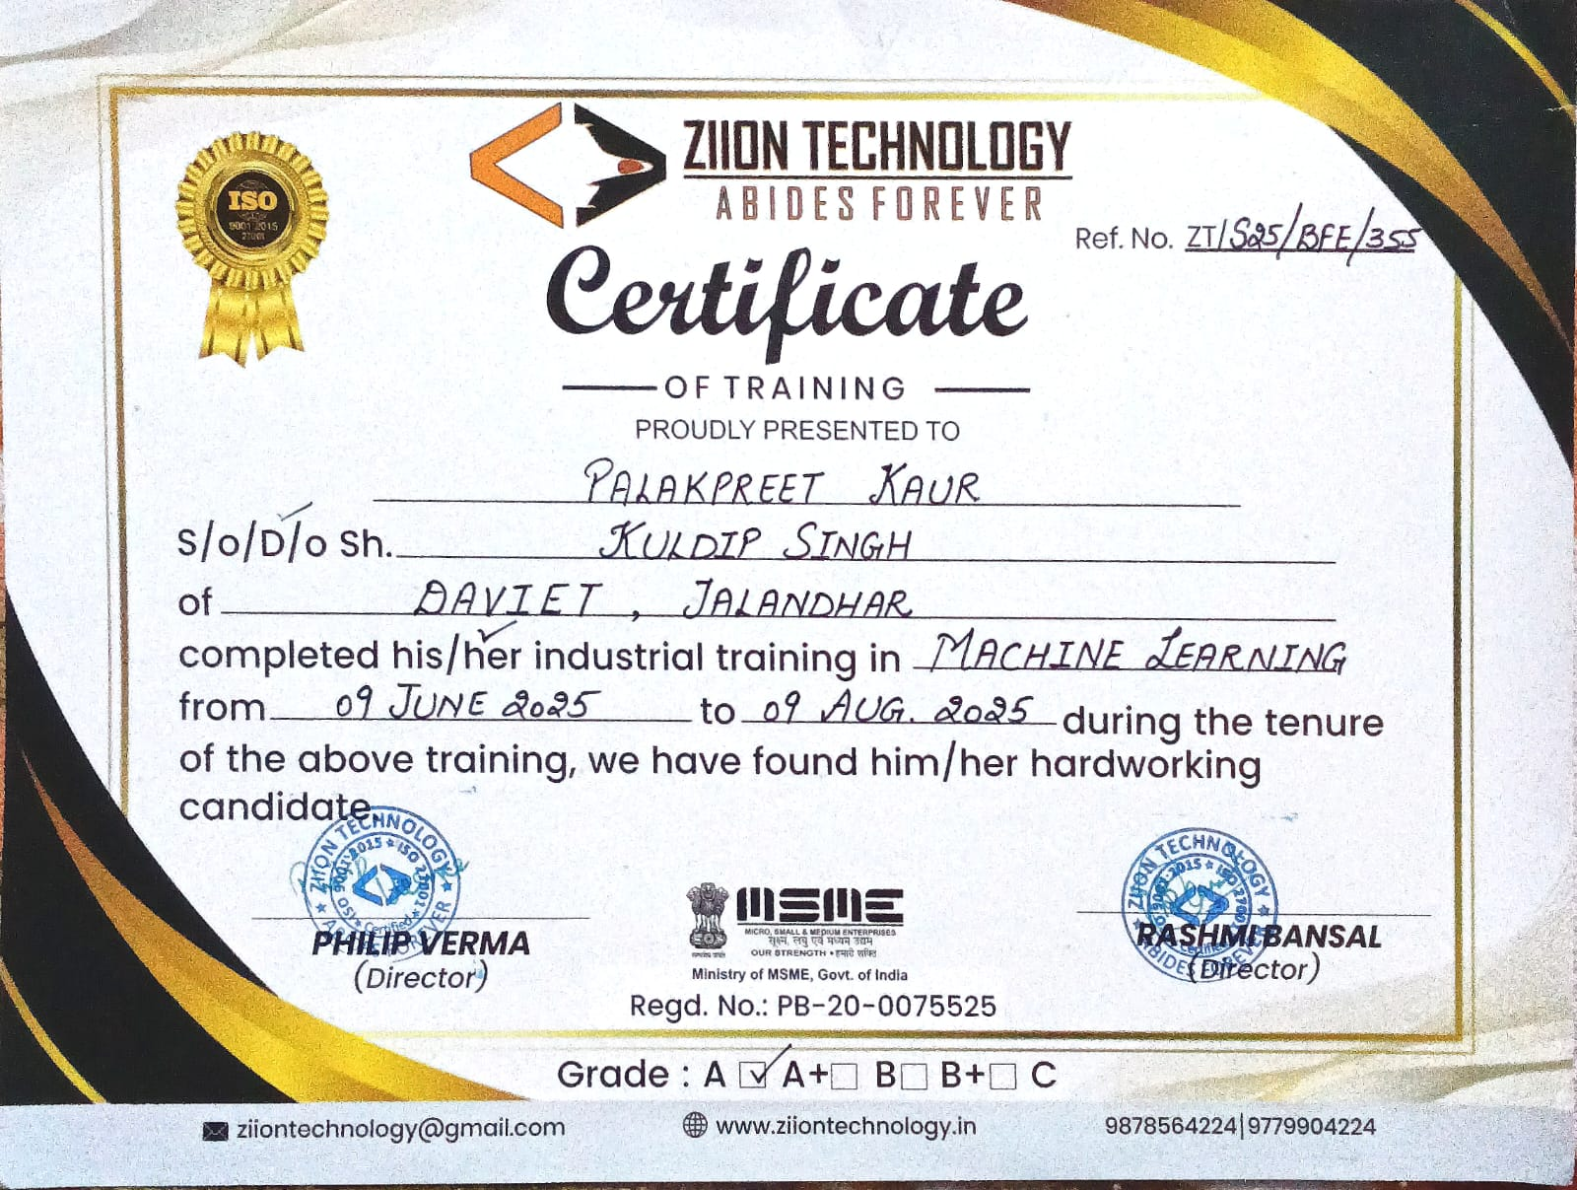

TRAINING EVALUATION REPORT
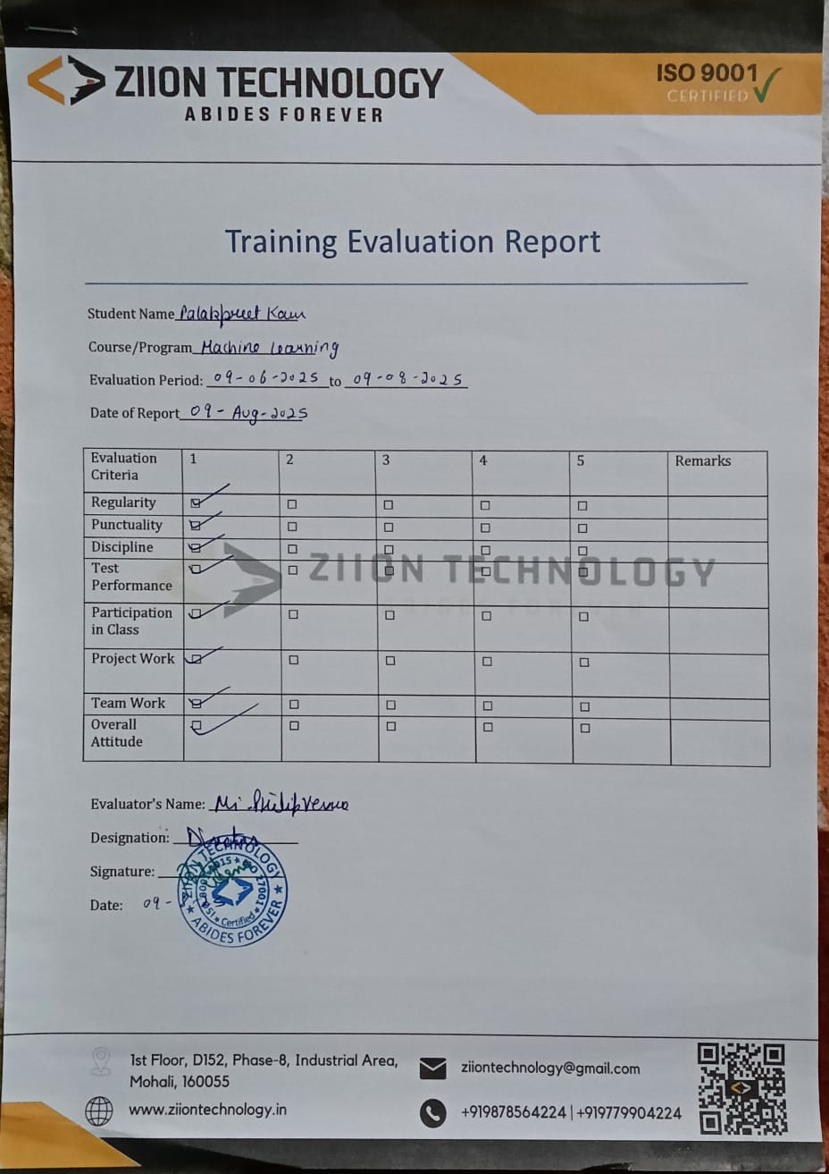
ACKNOWLEDGEMENT
I express my sincere gratitude to the Department of Computer Science and Engineering (AIML), DAV Institute of Engineering and Technology, Jalandhar, for providing me with the opportunity to undergo industrial training as a part of the B.Tech curriculum. This training has helped me bridge the gap between theoretical knowledge and practical application.
I am thankful to the Ziion Technologies and my industry mentor Mr Siddhant Bharti for their valuable guidance, continuous support, and encouragement throughout the training period. Their insights and suggestions played a crucial role in the successful completion of my project titled “Brain Tumor Detection Using Machine Learning.”
I would also like to thank my faculty members for their constant motivation, academic guidance, and timely feedback, which helped me understand the practical aspects of Machine Learning and Computer Vision.
Finally, I extend my heartfelt thanks to my parents and friends for their constant encouragement and moral support throughout the training period. This training experience has been highly beneficial and has significantly enhanced my technical skills, confidence, and understanding of real-world applications of Machine Learning.

ABSTRACT
The industrial training was undertaken with the objective of gaining practical exposure to real-world applications of Machine Learning and Computer Vision and understanding their implementation in solving healthcare-related problems. The training was carried out under an industrial training program, where guidance, learning resources, and practical assignments were provided to develop technical and analytical skills relevant to the field of Artificial Intelligence and Machine Learning.
During the training period, a project titled “Brain Tumor Detection Using Machine Learning” was developed. The project involved working with MRI brain images to classify different types of brain tumors such as Glioma, Meningioma, Pituitary Tumor, and No Tumor. The work included dataset analysis, image preprocessing using techniques like grayscale conversion, resizing, normalization, and feature extraction. A Support Vector Machine (SVM) classifier was trained and evaluated using standard performance metrics such as accuracy, precision, recall, and F1-score. Furthermore, the trained model was deployed using the Flask web framework, enabling users to upload MRI images and obtain prediction results through a web interface.
Through this training, valuable learning outcomes were achieved, including a strong understanding of the complete machine learning pipeline, hands-on experience with Python-based ML libraries, and practical knowledge of model deployment. The training enhanced problem-solving abilities, technical proficiency, and confidence in applying machine learning techniques to real-world healthcare applications.

Table of content
Section | Title | Page No.
1 | Introduction | 8
1.1 | Purpose of Industrial Training | 8
1.2 | Importance of Industrial Training in Engineering Education | 8
1.3 | Overview of the Company | 9
2 | Company Profile | 11
2.1 | Introduction to the Organization | 11
2.2 | Vision and Mission of the Organization | 11
2.3 | Services and Areas of Expertise | 11
2.4 | Training Methodology and Learning Environment | 12
2.5 | Infrastructure and Technical Resources | 12
2.6 | Role of Mentors and Industry Experts | 13
3 | Training Details | 14
3.1 | Training Duration and Schedule | 14
3.2 | Overview of the Project | 14
3.3 | Week-wise Training Details and Work Done | 15
3.4 | Tools, Software, and Technologies Used | 18
3.5 | Practical Work Performed | 19
3.6 | Screenshots, Diagrams, and Documentation | 20
4 | Learning Outcomes, Observations, And Results | 26
4.1 | Introduction | 26
4.2 | Learning Outcomes | 26
4.3 | Observations During Training | 27
4.4 | Results Obtained | 28
4.5 | Overall Impact of Training | 29
5 | Conclusion | 30
5.1 | Overall Training Experience | 30
5.2 | Importance of Industrial Training | 30
5.3 | Enhancement of Practical Knowledge | 30
6 | APPENDICES | 32
 | Appendix A: Daily Diary | 32
 | Appendix B: Project Code Overview | 33

ABBREVIATIONS

Abbreviation | Full Form
AI | Artificial Intelligence
ML | Machine Learning
SVM | Support Vector Machine
MRI | Magnetic Resonance Imaging
CV | Computer Vision
GUI | Graphical User Interface
IDE | Integrated Development Environment
DFD | Data Flow Diagram

INTRODUCTION
1.1 Purpose of Industrial Training
Industrial training is an integral part of the engineering curriculum that aims to bridge the gap between theoretical knowledge gained in classrooms and its practical application in real-world environments. The primary purpose of industrial training is to provide students with hands-on exposure to industry-oriented tools, technologies, methodologies, and professional work culture. It allows students to understand how theoretical concepts are implemented to solve real-life problems efficiently and effectively.
In the rapidly evolving field of Computer Science and Engineering, especially in domains such as Artificial Intelligence and Machine Learning, practical knowledge is as important as theoretical understanding. Industrial training enables students to apply programming concepts, algorithms, and problem-solving techniques to industry-relevant projects. It helps in developing analytical thinking, logical reasoning, and technical proficiency, which are essential for a successful engineering career.
The purpose of this industrial training was to gain practical exposure to Machine Learning, Computer Vision, and application development while working on a real-world problem in the healthcare domain. The training focused on understanding the complete lifecycle of a machine learning project, including data collection, preprocessing, model selection, training, evaluation, and deployment. Through this training, emphasis was placed on learning industry practices, coding standards, and systematic project development approaches.
Additionally, industrial training helps students become familiar with professional ethics, teamwork, communication skills, and time management. It prepares students for future employment by enhancing their confidence and making them industry-ready. Overall, the purpose of industrial training is to transform students from learners into skilled professionals capable of contributing effectively to the industry.
1.2 Importance of Industrial Training in Engineering Education
Industrial training holds significant importance in engineering education as it provides a platform for students to experience real-world challenges and understand industry expectations. Engineering education is not limited to acquiring theoretical knowledge; it also focuses on developing practical skills that enable students to design, develop, test, and deploy solutions in real-time environments. Industrial training plays a crucial role in achieving this objective.
One of the major advantages of industrial training is that it helps students understand the practical relevance of subjects studied during their academic coursework. Concepts learned in areas such as programming, data structures, machine learning algorithms, and software development become more meaningful when applied to real projects. This practical exposure enhances conceptual clarity and strengthens problem-solving abilities.
Industrial training also introduces students to the latest technologies, tools, and frameworks used in the industry. With rapid advancements in Artificial Intelligence, Machine Learning, and Data Science, it is essential for students to stay updated with current trends. Training programs help students learn modern libraries, development environments, and deployment platforms, thereby increasing their employability.
Furthermore, industrial training helps students develop soft skills such as communication, teamwork, adaptability, and professionalism. Working on projects under deadlines and collaborating with mentors and peers improves interpersonal skills and work ethics. These skills are equally important as technical knowledge in the professional world.
In the context of engineering education, industrial training serves as a foundation for future career growth. It helps students identify their areas of interest, understand industry requirements, and make informed career choices. Overall, industrial training enhances the quality of engineering education by producing competent, skilled, and industry-ready graduates.
1.3 Overview of the Company
The industrial training was carried out at Ziion Technologies, located in Mohali, Punjab. Ziion Technologies is a dynamic and forward-looking technology company that specializes in providing advanced solutions in the fields of Artificial Intelligence (AI), Machine Learning (ML), Data Science, web and mobile application development, and digital transformation services. With a strong focus on innovation and industry-relevant skill development, Ziion Technologies has positioned itself as a reputable training and solution provider for students, professionals, and corporate clients.
Established with the mission of bridging the gap between academic learning and industry requirements, Ziion Technologies offers structured training programs that combine theoretical fundamentals with extensive practical exposure. The organization places emphasis on experiential learning through real-world projects, guided mentorship, and continuous performance evaluation. By adopting an industry-driven curriculum, trainees are introduced to the latest technological tools, frameworks, and best coding practices used in professional environments.
During the training period, the organization facilitated an interactive learning environment where trainees were encouraged to explore cutting-edge technologies such as Machine Learning, Computer Vision, Backend and Frontend Development, and application deployment techniques. Special focus was given to hands-on project work, enabling trainees to apply their skills to solve complex problems. Towards this objective, mentors from the company provided consistent guidance, insightful feedback, and support throughout the project life cycle.
Ziion Technologies also encourages a collaborative culture that enhances teamwork, communication skills, and professional ethics. The experience at the organization exposed trainees to real-life industry workflows, performance expectations, and project development standards. Overall, Ziion Technologies played an instrumental role in enriching the industrial training experience by equipping trainees with practical knowledge, technical expertise, and confidence necessary for future career success in the field of technology.

COMPANY PROFILE
2.1 Introduction to the Organization
Ziion Technologies is a reputed technology-based organization located in Mohali, Punjab, known for its expertise in providing training, development, and consultancy services in emerging domains of computer science. The organization focuses on delivering high-quality technical solutions and industry-oriented training in areas such as Artificial Intelligence, Machine Learning, Data Science, Web Development, Software Development, and related advanced technologies.
Ziion Technologies was established with the vision of bridging the gap between academic knowledge and industrial requirements. The organization understands the rapidly changing demands of the IT industry and continuously updates its training methodologies and project frameworks to align with current technological trends. Through its structured programs, Ziion Technologies aims to nurture skilled professionals who are capable of solving real-world problems using modern tools and techniques.
2.2 Vision and Mission of the Organization
Vision
The vision of Ziion Technologies is to become a leading technology training and solution provider by empowering students and professionals with practical skills, innovative thinking, and industry-ready expertise. The organization strives to contribute to technological growth by promoting learning, research, and development in advanced computing fields.
Mission
The mission of Ziion Technologies is to:
- Provide industry-oriented training programs that emphasize practical implementation.
- Equip students with hands-on experience through real-world projects.
- Foster innovation, creativity, and analytical thinking.
- Bridge the skill gap between academic learning and professional requirements.
- Prepare trainees for successful careers in the IT and software industry.
2.3 Services and Areas of Expertise
Ziion Technologies offers a wide range of services and training programs designed to meet the needs of students, professionals, and organizations. The major areas of expertise include:
- Artificial Intelligence and Machine Learning
- Data Science and Data Analytics
- Computer Vision and Image Processing
- Web Application Development
- Software Development and Testing
- Python Programming
- Cloud Computing (Introductory level)
- Project Development and Industrial Training
The organization provides end-to-end guidance for project development, from requirement analysis and system design to implementation, testing, and documentation. This approach ensures that trainees gain comprehensive exposure to professional software development practices.
2.4 Training Methodology and Learning Environment
Ziion Technologies follows a structured and practical training methodology that emphasizes experiential learning. The training programs are designed to provide a balance between theoretical concepts and hands-on implementation. The learning environment encourages curiosity, problem-solving, and independent thinking.
Key features of the training methodology include:
- Conceptual explanation of core topics
- Live coding and demonstrations
- Hands-on practice sessions
- Real-time project development
- Regular assessments and feedback
- One-to-one mentoring support
The organization provides access to modern development tools, programming environments, and datasets required for project implementation. Trainees are encouraged to work on real-world problem statements, which helps them understand industry workflows and best practices.
2.5 Infrastructure and Technical Resources
Ziion Technologies is equipped with the necessary infrastructure and technical resources to support effective learning and project development. The organization provides:
- Well-equipped training labs
- High-performance computing systems
- Internet connectivity and software tools
- Access to development environments and libraries
- Learning materials and reference resources
These facilities enable trainees to work efficiently on complex projects and explore advanced concepts in Machine Learning and software development without technical limitations.
2.6 Role of Mentors and Industry Experts
One of the key strengths of Ziion Technologies is the availability of experienced mentors and technical experts like sidhant Bharti. The mentors guide trainees throughout the training period by:
- Clarifying theoretical concepts
- Assisting in practical implementation
- Providing project guidance
- Reviewing code and documentation
- Offering performance feedback
Mentors play an important role in shaping the learning experience by sharing their industry knowledge and practical insights. Their guidance helps trainees overcome challenges and develop confidence in applying technical skills.

TRAINING DETAIL
3.1 Training Duration and Schedule
The industrial training was undertaken as a Post First Year Industrial Training for a duration of two months, in accordance with the academic requirements of the B.Tech program. The primary objective of this training was to provide early exposure to industry practices and to help students understand the practical application of fundamental engineering concepts.
The two-month training program was systematically planned and executed to ensure a balanced combination of theoretical learning and practical implementation. Since this training was conducted after the first year of the engineering program, emphasis was placed on building a strong foundation in programming, Machine Learning basics, and problem-solving skills rather than advanced specialization.
The training schedule was divided into weekly modules, with each week focusing on specific learning objectives. The initial weeks were dedicated to understanding core concepts such as Python programming, basic Machine Learning principles, and an introduction to Computer Vision. The subsequent weeks focused on practical implementation, including image preprocessing, dataset handling, and model training. The final phase of the training concentrated on project integration, testing, deployment, and documentation.
Regular mentoring sessions, practice assignments, and project reviews were conducted throughout the training period to monitor progress and enhance learning outcomes. The structured two-month duration provided sufficient time to understand the fundamentals of Machine Learning and to successfully develop a project titled “Brain Tumor Detection Using Machine Learning.” Overall, the post first year industrial training proved to be highly beneficial in strengthening technical foundations and preparing for advanced studies in later semesters.
3.2 Overview of the Project
As part of the industrial training, a project titled “Brain Tumor Detection Using Machine Learning” was developed. The main objective of the project was to design and implement a machine learning-based system capable of identifying and classifying brain tumors using MRI images.
The project aimed to simulate a real-world healthcare application where Machine Learning techniques assist in medical diagnosis. The system classifies MRI images into four categories: Glioma, Meningioma, Pituitary Tumor, and No Tumor. The project involved complete end-to-end development, including data preprocessing, model training, evaluation, and deployment using a web interface.

3.3 Week-wise Training Details and Work Done
Week 1: Introduction to Programming and Python Basics
The first week of the training was dedicated to understanding the fundamentals of programming with a primary focus on Python, which is widely used in Machine Learning and data processing. Since this was post first year training, emphasis was placed on building a strong programming foundation.
The activities performed during this week included:
- Introduction to programming concepts
- Understanding Python syntax and structure
- Variables, data types, and operators
- Conditional statements (if–else)
- Looping constructs (for and while loops)
- Basic input/output operations
Practical exercises were performed to strengthen logical thinking and coding skills. Simple Python programs were written to implement conditional logic and looping concepts.
Week 2: Advanced Python Concepts and Libraries
In the second week, more advanced Python concepts were introduced along with commonly used libraries. This week aimed to prepare students for handling data and implementing Machine Learning workflows.
The tasks performed during this week included:
- Functions and modular programming
- Lists, tuples, sets, and dictionaries
- File handling in Python
- Exception handling
- Introduction to NumPy and Pandas libraries
- Basic data manipulation and analysis
- Build library management system
- Build shopping cart system for practice using python
- Build flight booking system
Hands-on practice was carried out using Python scripts to work with arrays, datasets, and files. This week helped in developing confidence in Python programming.

Week 3: Basics of Machine Learning
The third week was dedicated to understanding the fundamental concepts of Machine Learning. This week provided the theoretical foundation required for further project development.
Topics covered during this week included:
- Introduction to Machine Learning and its importance
- Difference between Artificial Intelligence and Machine Learning
- Types of Machine Learning: Supervised, Unsupervised, and Reinforcement Learning
- Basic Machine Learning workflow
- Understanding features, labels, and datasets
- Introduction to training and testing concepts
- Overfitting and underfitting (basic understanding)
Week 4: Introduction to Machine Learning Algorithms
In the fourth week, we were introduced to Machine Learning algorithms and focused on supervised learning algorithms. This week emphasized both theoretical understanding and practical implementation.
Topics covered during this week included:
- Introduction to different Machine Learning algorithms
- Understanding the difference between supervised, unsupervised, and reinforcement learning
- Focus on supervised learning algorithms and their applications
- Detailed explanation and hands-on implementation of algorithms such as:
  - Linear Regression – for predicting continuous values
  - Decision Trees – for classification and regression tasks
- Steps involved in supervised learning: data preprocessing, model training, testing, and evaluation
- Understanding model performance metrics such as accuracy
- Practical examples to understand how models learn patterns from labeled data to make predictions
The practical sessions provided a clear understanding of how supervised algorithms work, how to train models with labeled datasets, and how to evaluate their performance. This week laid a strong foundation for applying Machine Learning models in real-world projects in the upcoming weeks.
Week 5: Introduction to Unsupervised Machine Learning
In the fifth week, we were introduced to Unsupervised Machine Learning (UML), which deals with analyzing and finding patterns in unlabeled data. Unlike supervised learning, unsupervised algorithms do not require predefined outputs; instead, they aim to identify hidden structures, groupings, or relationships within the data.
Topics covered included:
- Understanding the concept and importance of unsupervised learning
- Differences between supervised and unsupervised learning
- Overview of common unsupervised algorithms such as K-Means Clustering, Hierarchical Clustering
- Practical applications of unsupervised learning in data analysis, market segmentation, and pattern recognition
- Basic workflow: data preprocessing, applying the algorithm, analyzing results, and visualization
This week provided a foundational understanding of how unsupervised algorithms uncover insights from unlabeled data, preparing us for hands-on implementation and data exploration in practical sessions.
Weeks 6: Image Preprocessing and Model Training
During Weeks 3 and 4, the project focused on preparing MRI images for classification and building the machine learning model.
Image Preprocessing:
- Read MRI images using OpenCV
- Converted images to grayscale
- Resized images to 100 × 100 pixels
- Normalized pixel values
- Flattened images into feature vectors
Feature Extraction and Model Training:
- Converted preprocessed images into numerical features
- Assigned labels based on dataset categories
- Split dataset into training and testing sets
- Applied Support Vector Machine (SVM) for classification
- Trained and saved the SVM model
These steps ensured dataset uniformity and effective model performance, enabling accurate MRI image classification.
Week 7: Testing, Debugging, and Optimization
During the seventh week, extensive testing and optimization were performed to improve system reliability:
- Testing system with multiple MRI images
- Handling invalid file uploads
- Improving prediction response time
- Fixing errors and bugs
- Improving overall application stability
Week 8: Web Application Development and Documentation
The final week focused on deployment and documentation.
Work performed:
- Introduction to Flask web framework
- Integrating trained ML model with Flask
- Creating a user interface for image upload
- Displaying prediction results
- Preparing project documentation and training report
This week concluded the training with successful project completion.
3.4 Tools, Software, and Technologies Used
During the training, a combination of programming languages, libraries, frameworks, and tools were utilized to build and implement the machine learning project effectively. Each tool was selected based on its suitability for the tasks involved, from image preprocessing to model deployment. The details are as follows:
1. Programming Language: Python
Python was chosen as the primary programming language due to its simplicity, readability, and extensive support for data science and machine learning tasks. Its large ecosystem of libraries made it ideal for handling image processing, data analysis, and building machine learning models.
2. Libraries
- NumPy: Used for numerical computations and handling multi-dimensional arrays. It is essential for mathematical operations required during data preprocessing and feature extraction.
- Pandas: Provided data structures and functions for efficiently managing datasets, including reading, cleaning, and manipulating structured data.
- OpenCV: Used for image processing tasks such as reading MRI images, resizing, converting to grayscale, and normalization. OpenCV provides fast and optimized functions for computer vision applications.
- Scikit-learn: A versatile machine learning library that was used to implement algorithms, split datasets, perform model evaluation, and apply preprocessing techniques like normalization and scaling.
3. Machine Learning Algorithm: Support Vector Machine (SVM)
Support Vector Machine (SVM) was implemented for classification tasks. SVM is a supervised learning algorithm that works well for both linear and non-linear data. It was used due to its effectiveness in handling high-dimensional data such as flattened MRI images and its robustness in achieving high classification accuracy.
4. Web Framework: Flask
Flask was used to develop a lightweight web application for deploying the trained machine learning model. It allowed creating REST APIs and integrating the model with a frontend interface for user interaction, making the application accessible via a web browser.
5. Frontend: HTML and CSS
HTML (HyperText Markup Language) and CSS (Cascading Style Sheets) were used for designing the user interface of the web application. HTML structured the content while CSS styled the pages, ensuring the application was user-friendly and visually appealing.
6. IDE (Integrated Development Environment): Visual Studio Code / Jupyter Notebook
- Visual Studio Code (VS Code): Used for writing and managing Python code, debugging, and integrating with Git for version control.
- Jupyter Notebook: Utilized for interactive development, testing, and visualization of machine learning workflows, especially during the preprocessing and model training phases.
7. Operating System: Windows
The development environment was set up on Windows, providing compatibility with the required software and libraries. Windows OS allowed easy installation of Python, IDEs, and other tools, and ensured smooth execution of scripts and web applications.
3.5 Practical Work Performed
The practical work focused on applying machine learning to MRI image analysis. Key tasks included:
- Image Preprocessing:
  - MRI images were preprocessed using Python and OpenCV: converted to grayscale, resized (100 × 100 pixels), normalized, and flattened.
  - This ensured uniformity and improved model performance.
- Machine Learning Model Implementation:
  - A Support Vector Machine (SVM) was trained on the preprocessed dataset to classify images as normal or abnormal.
  - The dataset was split into training and testing sets, and model performance was evaluated using accuracy, precision, recall, and F1-score.
- Web-Based Application Development:
  - A Flask-based web interface was created to deploy the trained model.
  - Users could upload MRI images and get real-time classification results.
- Testing and Evaluation:
  - The system was tested with real MRI scans, and misclassifications were analyzed to refine preprocessing and training.
Overall, the practical work provided hands-on experience in dataset preprocessing, ML model training, evaluation, and deployment.
3.6 Screenshots, Diagrams, and Documentation
1. Image Preprocessing Steps
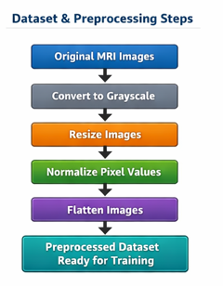

2. Model Training Workflow
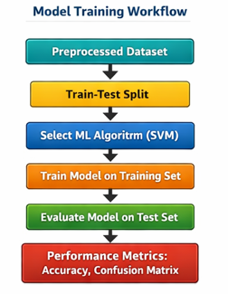
3. Web Application workflow

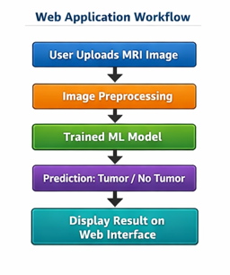

4. Dataset Samples
A. Glioma
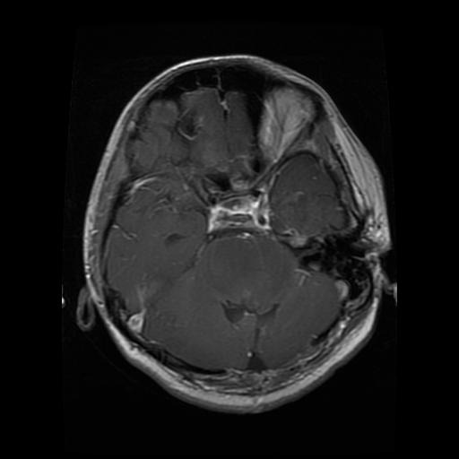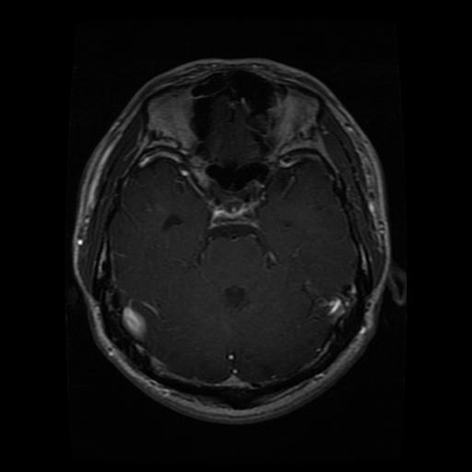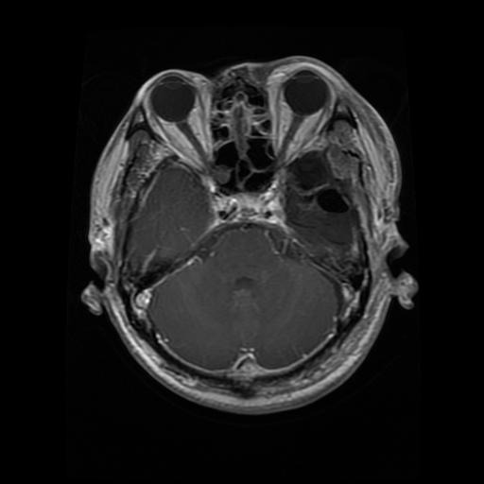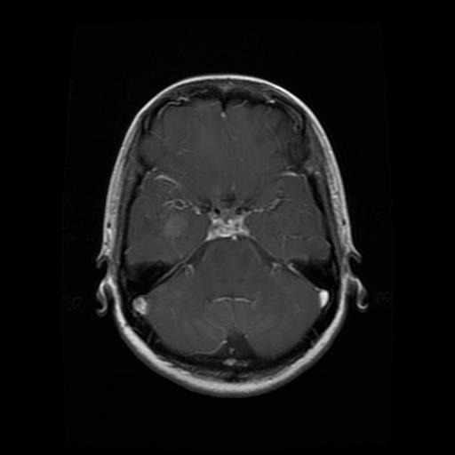
B. Meningioma
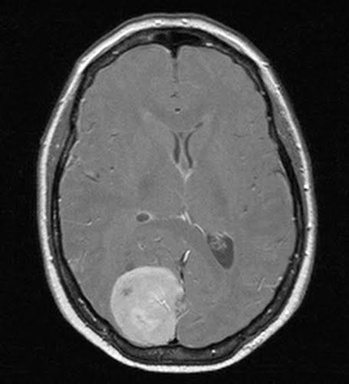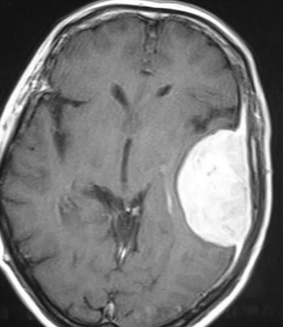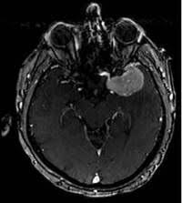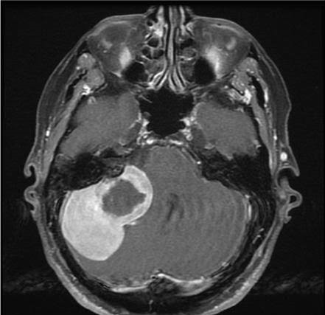
C. Notumor
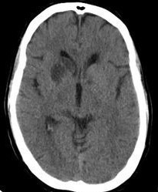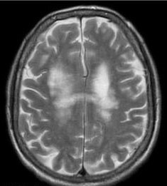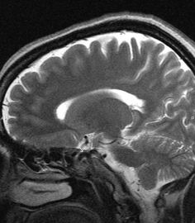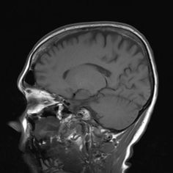
D. Pituitary
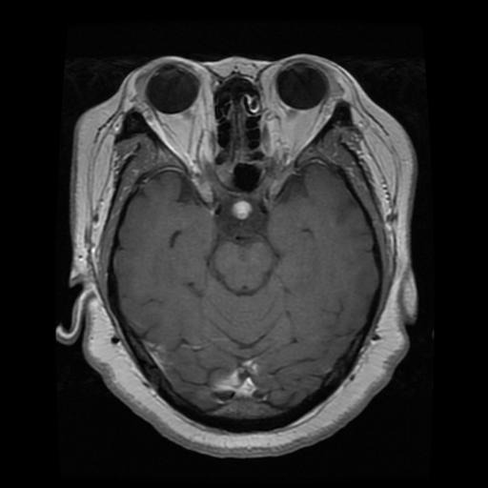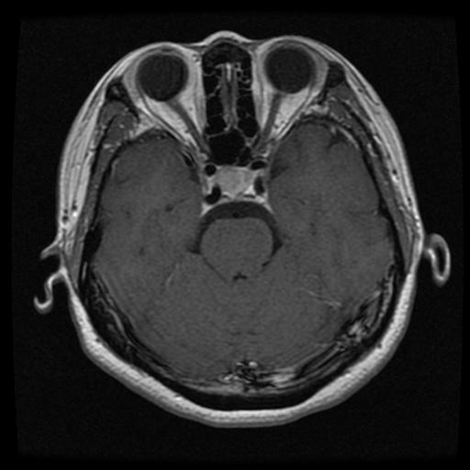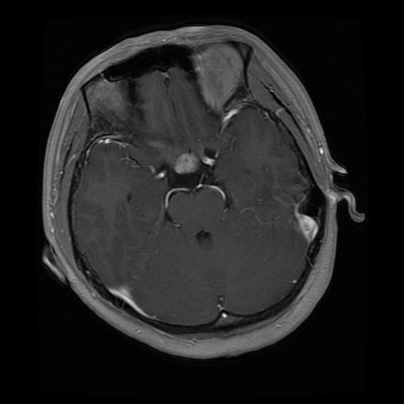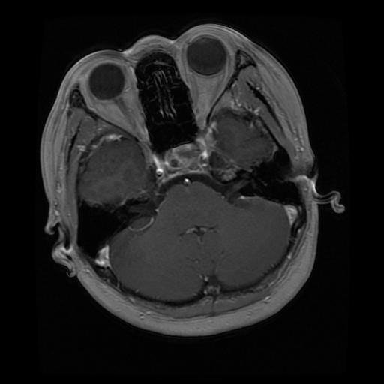
5. Results
Home Interface
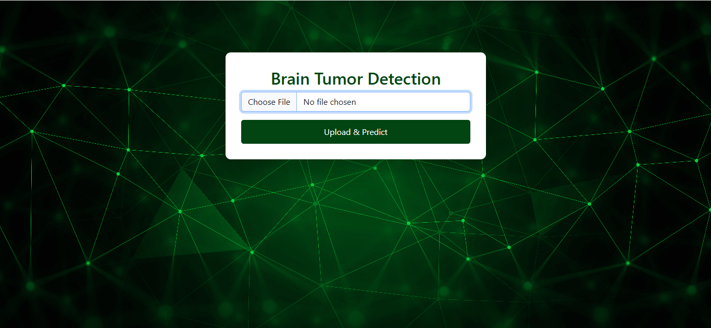
Input MRI image
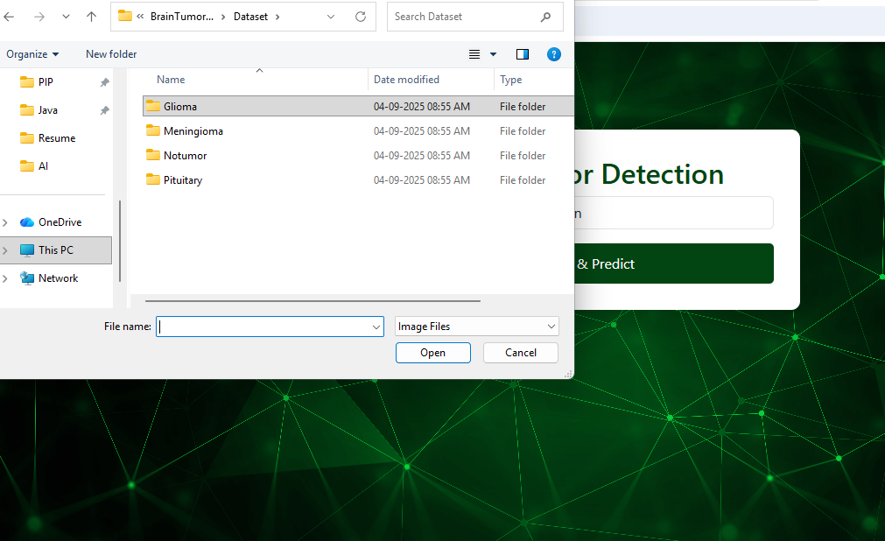
Upload and predict
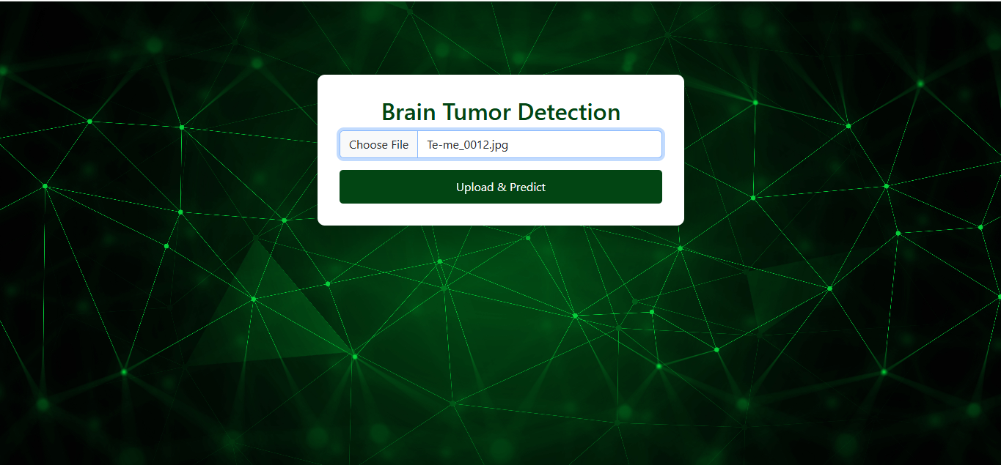
Prediction Result
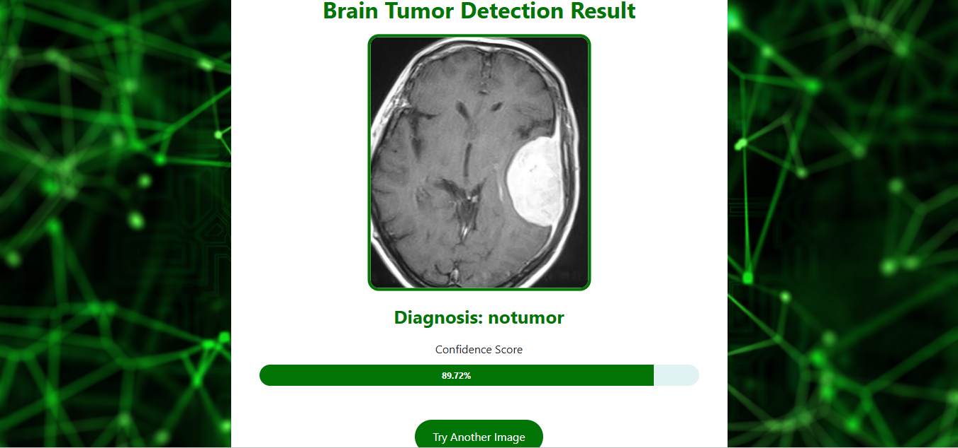

Try another MRI Image
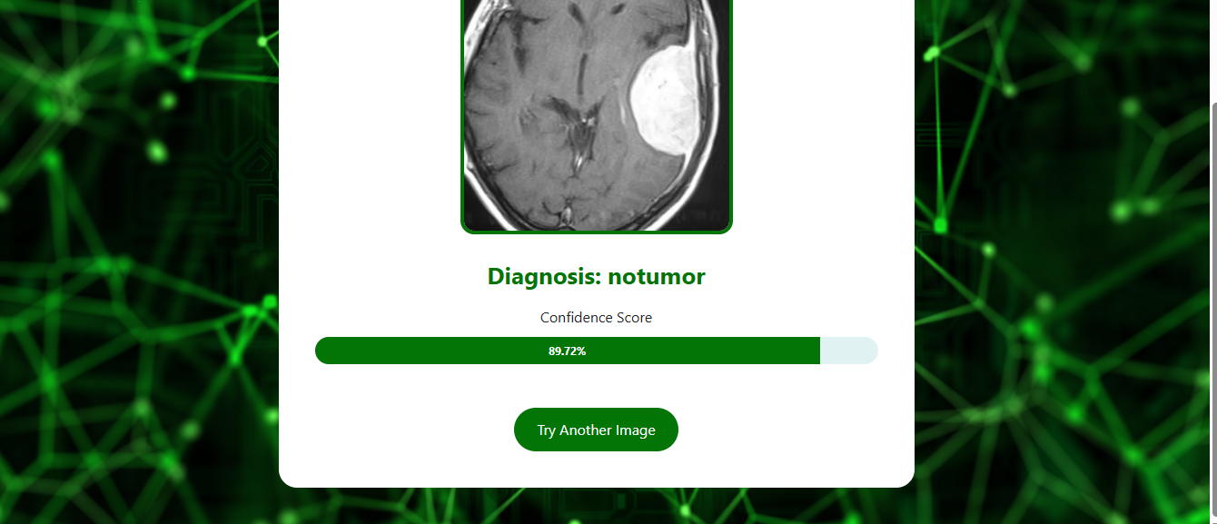

LEARNING OUTCOMES, OBSERVATIONS, AND RESULTS
4.1 Introduction
Industrial training plays a crucial role in transforming theoretical knowledge into practical skills. This chapter presents the key learning outcomes, observations made during the training period, and the results obtained from the successful implementation of the project titled “Brain Tumor Detection Using Machine Learning.” The chapter highlights the technical, analytical, and professional skills developed during the training, along with practical insights gained while working on a real-world healthcare application.
The training experience provided hands-on exposure to the complete Machine Learning project lifecycle, including data handling, preprocessing, model development, evaluation, and deployment. It also helped in understanding industry-oriented workflows, problem-solving techniques, and best practices followed in professional environments.
4.2 Learning Outcomes
The industrial training resulted in significant academic, technical, and professional learning outcomes. These outcomes contributed to overall skill enhancement and preparedness for advanced studies and future professional roles.
4.2.1 Technical Learning Outcomes
During the training, strong technical foundations were developed in the following areas:
- Python Programming Proficiency
The training enhanced proficiency in Python programming, including control structures, functions, file handling, exception handling, and modular programming. Python was extensively used for data processing, image manipulation, and model implementation.
- Understanding of Machine Learning Concepts
A clear understanding of fundamental Machine Learning concepts such as supervised and unsupervised learning, training and testing datasets, feature extraction, model evaluation, overfitting, and underfitting was achieved.
- Hands-on Experience with Machine Learning Algorithms
Practical exposure to algorithms such as Linear Regression, Decision Trees, and Support Vector Machine (SVM) helped in understanding their working principles and real-world applications. SVM was successfully implemented for MRI image classification.
- Image Processing and Computer Vision Skills
Knowledge of image preprocessing techniques such as grayscale conversion, resizing, normalization, and feature vector generation was gained using OpenCV. These techniques were crucial for preparing MRI images for model training.
- Model Evaluation and Performance Metrics
Learned to evaluate machine learning models using metrics such as accuracy, precision, recall, and F1-score. Understanding confusion matrices helped in analyzing classification results.
- Web Application Development and Deployment
Gained practical knowledge of deploying a trained ML model using the Flask web framework. Integration of backend ML logic with frontend HTML and CSS provided exposure to full-stack development concepts.
4.2.2 Analytical and Problem-Solving Skills
The training significantly improved analytical thinking and problem-solving abilities:
- Ability to analyze real-world problems and convert them into computational solutions.
- Selection of appropriate algorithms based on data characteristics.
- Identifying errors during model training and debugging code efficiently.
- Optimization of preprocessing steps to improve model accuracy.
- Handling invalid inputs and edge cases during application development.
4.2.3 Professional and Soft Skill Development
In addition to technical knowledge, several professional skills were developed:
- Communication Skills: Interaction with mentors and peers improved technical communication.
- Time Management: Weekly targets and deadlines enhanced task planning and execution.
- Teamwork and Collaboration: Learned to work in a structured training environment with guidance from industry experts.
- Professional Ethics: Exposure to industry standards, coding practices, and documentation techniques.
4.3 Observations During Training
Throughout the training period, several important observations were made that contributed to a deeper understanding of Machine Learning and industry practices.
4.3.1 Importance of Data Quality
One key observation was that the quality of data significantly impacts model performance. Proper preprocessing of MRI images was essential to achieve consistent and accurate classification results. Even minor inconsistencies in image size or pixel values affected prediction accuracy.
4.3.2 Role of Preprocessing in Image Classification
Image preprocessing was observed to be a critical step in medical image analysis. Techniques such as normalization and resizing improved model convergence and reduced computational complexity. Effective preprocessing helped the SVM model distinguish between tumor and non-tumor images more efficiently.
4.3.3 Algorithm Selection Matters
Choosing the right algorithm plays an important role in achieving optimal results. Support Vector Machine (SVM) was found to perform well for high-dimensional image data and provided reliable classification results compared to simpler classifiers.
4.3.4 Importance of Model Evaluation
It was observed that evaluating the model using multiple metrics is essential rather than relying only on accuracy. Metrics such as precision and recall are especially important in medical applications where false negatives can have serious consequences.
4.3.5 Industry-Oriented Development Practices
The training highlighted the importance of clean code, proper documentation, modular design, and testing. These practices ensured easier debugging, scalability, and maintainability of the application.
4.4 Results Obtained
The project successfully achieved its intended objectives. The results obtained demonstrate the effectiveness of the implemented Machine Learning model and the overall system.
4.4.1 Model Performance Results
- The SVM classifier achieved satisfactory accuracy in classifying MRI images into four categories: Glioma, Meningioma, Pituitary Tumor, and No Tumor.
- The model performed consistently on both training and testing datasets.
- Performance evaluation using precision, recall, and F1-score indicated balanced classification results.
4.4.2 System Functionality Results
- The Flask-based web application successfully allowed users to upload MRI images.
- The system processed uploaded images in real-time and displayed prediction results accurately.
- The user interface was simple, responsive, and easy to use.
4.4.3 Reliability and Usability
- The application handled invalid inputs effectively.
- Prediction time was optimized for quick response.
- The system demonstrated reliable performance during multiple test runs.
4.5 Overall Impact of Training
The industrial training proved to be highly beneficial in enhancing both technical expertise and professional readiness. It provided a clear understanding of how Machine Learning can be applied to solve real-world healthcare problems. The project strengthened confidence in developing end-to-end ML solutions and motivated further exploration in advanced areas such as Deep Learning and Medical Image Analysis.
This training experience has laid a strong foundation for future academic projects, internships, and professional opportunities in the field of Artificial Intelligence and Machine Learning.

CONCLUSION
5.1 Overall Training Experience
The industrial training undertaken at Ziion Technologies was a valuable and enriching learning experience. It provided an excellent opportunity to apply theoretical concepts learned during academic coursework to practical, real-world problems. Working on the project titled “Brain Tumor Detection Using Machine Learning” allowed exposure to the complete lifecycle of a machine learning application, from understanding the problem statement to deployment of the final system.
The training environment was well-structured and supportive, with continuous guidance from industry mentors. Regular practice sessions, project reviews, and hands-on implementation helped in building confidence and developing a deeper understanding of Machine Learning and Computer Vision concepts. The experience also introduced professional work culture, discipline, and systematic problem-solving approaches, making the training both educational and practical.
5.2 Importance of Industrial Training
Industrial training plays a vital role in engineering education by bridging the gap between academic learning and industry requirements. Classroom learning provides theoretical knowledge, whereas industrial training offers practical exposure to tools, technologies, and methodologies used in real-world applications. This training helped in understanding how Machine Learning solutions are developed, tested, and deployed in professional environments.
The training emphasized the importance of industry-oriented skills such as coding standards, documentation, testing, and debugging. It also highlighted the relevance of teamwork, communication, and time management in completing technical projects within deadlines. Exposure to real datasets and healthcare-based problem statements enhanced awareness of how technology can be used to solve critical societal issues.
Overall, the industrial training served as a foundation for future internships, projects, and professional roles by aligning academic knowledge with practical industry needs.
5.3 Enhancement of Practical Knowledge
The training significantly enhanced practical knowledge in the field of Artificial Intelligence and Machine Learning. Practical exposure to Python programming, image preprocessing, machine learning algorithms, and model evaluation strengthened technical proficiency. Working with MRI image datasets provided insight into medical image analysis and the challenges involved in handling real-world data.
Hands-on implementation of the Support Vector Machine (SVM) algorithm improved understanding of supervised learning techniques and performance evaluation metrics. Deployment of the trained model using the Flask web framework provided experience in building user-friendly applications and integrating backend logic with frontend interfaces.
The training also improved problem-solving abilities, analytical thinking, and debugging skills. Overall, the practical knowledge gained during the training has increased confidence in applying Machine Learning techniques to real-world problems and has laid a strong foundation for advanced studies and future professional opportunities in the field of Artificial Intelligence and Machine Learning.

APPENDICES
Appendix A: Daily Diary
This appendix presents a summarized record of the daily and weekly activities carried out during the industrial training period at Ziion Technologies. The logbook reflects systematic learning, regular practice, and continuous progress throughout the training duration.
Week 1: Introduction to Python Programming
- Introduction to programming fundamentals and Python environment setup
- Understanding variables, data types, operators, and basic syntax
- Practice of conditional statements and looping constructs
- Writing simple Python programs to strengthen logical thinking
Week 2: Advanced Python and Libraries
- Study of functions, lists, tuples, dictionaries, and file handling
- Exception handling and modular programming
- Introduction to NumPy and Pandas libraries
- Development of small Python-based applications such as a library management system and shopping cart system
Week 3: Machine Learning Fundamentals
- Introduction to Artificial Intelligence and Machine Learning
- Understanding supervised and unsupervised learning
- Study of ML workflow, datasets, features, and labels
- Concepts of training, testing, overfitting, and underfitting
Week 4: Machine Learning Algorithms
- Study of supervised learning algorithms
- Implementation of Linear Regression and Decision Trees
- Understanding classification and regression problems
- Evaluation of model performance using accuracy
Week 5: Unsupervised Learning
- Understanding clustering techniques
- Introduction to K-Means and Hierarchical Clustering
- Applications of unsupervised learning in data analysis
Week 6: Image Preprocessing and Model Training
- Loading MRI images using OpenCV
- Image preprocessing: grayscale conversion, resizing, normalization
- Feature extraction and dataset preparation
- Training Support Vector Machine (SVM) model
Week 7: Testing and Optimization
- Testing the model with multiple MRI images
- Debugging errors and handling invalid inputs
- Improving system reliability and performance
Week 8: Deployment and Documentation
- Introduction to Flask framework
- Integration of ML model with web application
- Development of user interface for image upload and prediction
- Preparation of project documentation and training report
Appendix B: Project Code Overview
The complete source code of the project “Brain Tumor Detection Using Machine Learning” was developed using Python and organized in a modular manner to ensure clarity and maintainability.
Major Code Modules:
- Data Preprocessing Module:
Handles image loading, resizing, grayscale conversion, and normalization.
- Model Training Module:
Implements the Support Vector Machine (SVM) algorithm using Scikit-learn.
- Model Evaluation Module:
Evaluates the trained model using accuracy, precision, recall, and F1-score.
- Flask Application Module:
Integrates the trained model with a web interface for user interaction.
- Frontend Files:
HTML and CSS files used to design the user interface.

